Since I will be applying some more changes in my model, I will start with a baseline run that is a bit faster than my last script. So I adjusted units to 256 and 512 and amount of epochs to 4.
Baseline run:
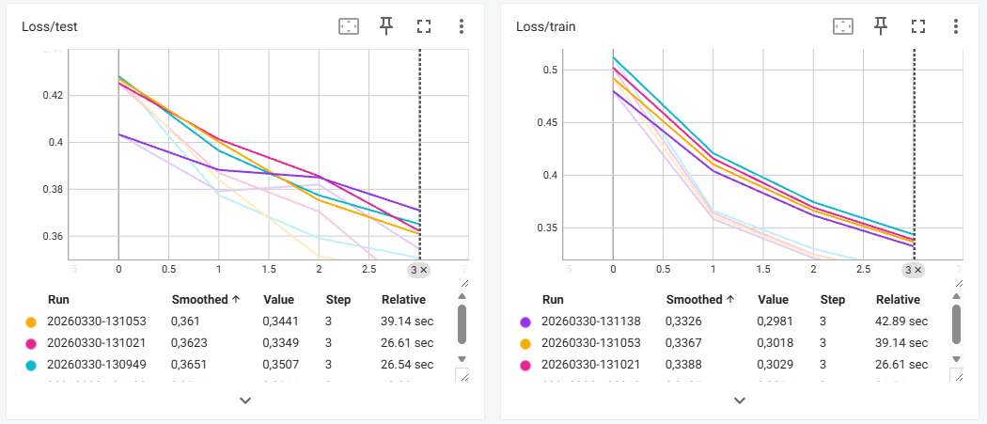
I will start with a hypothesis again.
After adding dropout, normalization, extra convolution layer and extra pooling layer, I expect the training loss and test loss to decrease, while I expect the metric value to improve. At the very least, I expect the generalization of the model to improve (especially after adding dropout).
My next run included dropout added of 0.1 after 2 layers. Results actually have gotten a bit worse, but I can imagine this happening since we are leaving out more information, hence the model will have a bit of a harder time to capture certain patterns (especially since I lowered the amount of epochs).
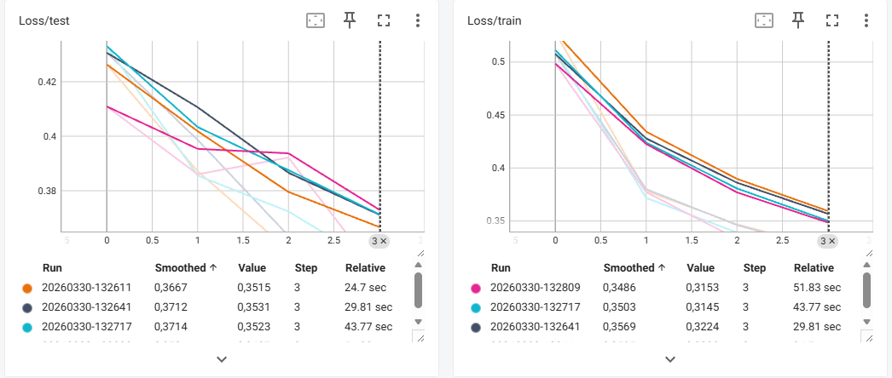
After including dropout, I added normalization and compared the results again. While still including dropout. So now we can see the results are actually improving beyond the baseline run.
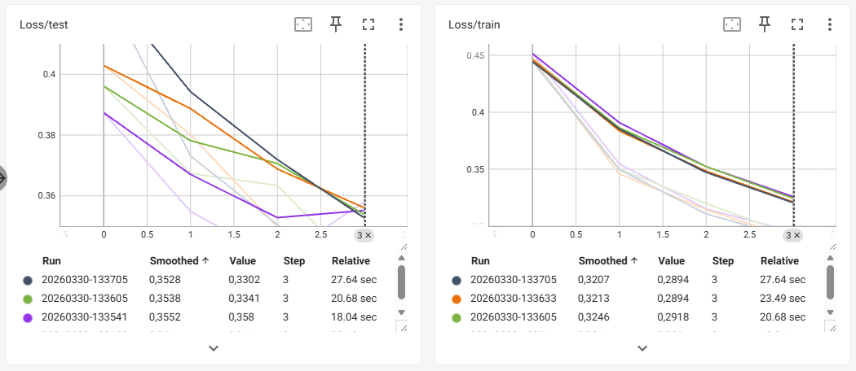
Now, convolutional and pooling added, which delivered an incredible improvement on both the training and test loss.
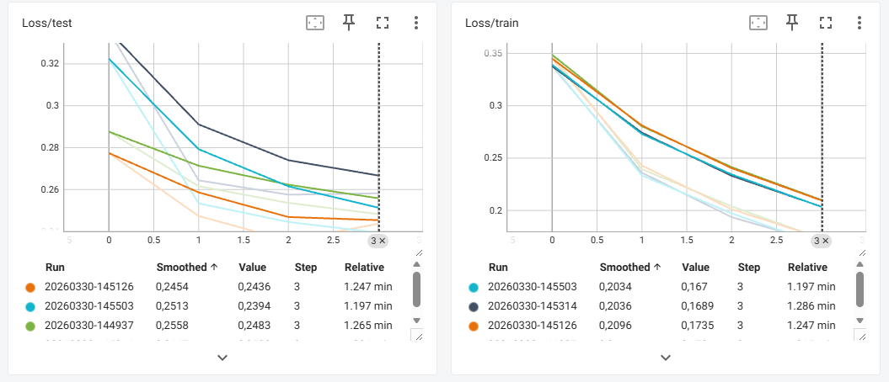
I did all of this using Tensor Board, but now I also added logic to log via MLFLOW and reran the latest run (including convolutional and pooling), so I can show that logging works via MLFLOW.
